if you want to **add a line, add a section and add a note** in **One2many** xml field, follow these steps:

**Step 1: Add display_type Field in the Inverse Model**

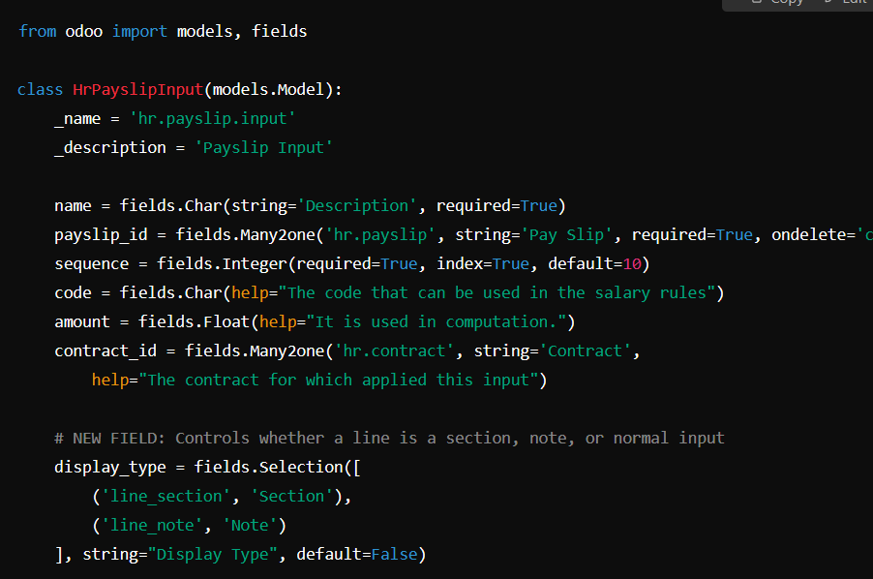

if set required=True of any field that time not set a display type value

that time use attrs=”{‘required’ : [(‘display_type’, ‘=’, False)]}” in xml side



attrs set particuler field is required

**Step 2: add a control in tree view of one2many field**

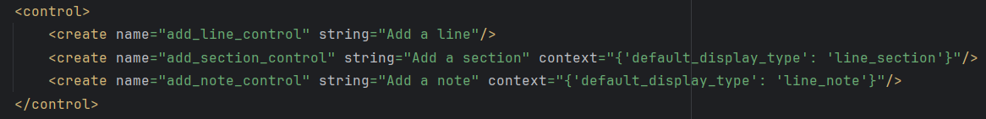

**Step 3: Add a widget for Enhanced Display**





* **Make a display_type field invisible**



**Full Tree view**

